Date:

Name:
Address:
City, State, Zip:

Dear:

We have received your contribution to the Fly Fishing Museum of the Southern Appalachians (FFMSA) for use in the FFMSA Permanent Collections at our facility in Cherokee, North Carolina. We deeply appreciate your generosity, (specify how the donation will help the FFMSA).

Your gift has been assigned an acquisition and identification number as follows:

ITEM DATE RECEIVED NUMBER
(Description) ___/___/___ ___.___.___

We have enclosed three copies of our Transfer of Ownership document for your signature and approval. Please sign two copies and return them in the envelope provided. The third copy of this will serve as your official receipt and will be sufficient documentation of the gift for income tax deduction purposes. Please sign and return as soon as possible.

FFMSA is a 501(c)3 non-profit organization. Your gift is tax deductible pursuant to IRS rule governing charitable contributions. FFMSA’s tax ID number is xx-xxxxxxx. This letter will serve as documentation for your records. No goods or services were provided in exchange for your contribution.

We cannot accomplish the Federation’s mission without gifts like yours. Your gift will make a difference in ensuring that future generations enjoy the fly fishing opportunities we have today. Thank you for your commitment to our sport and its heritage!

Thank you again for your support of the Fly Fishing Museum of the Southern Appalachians.

With sincere appreciation,
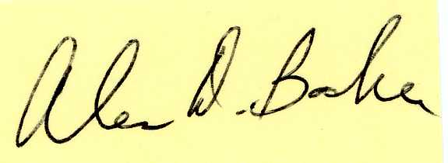
Alen Baker
Chairman of the Board
info@cherokeesmokies.com

